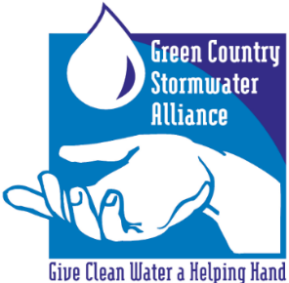
GCSA Workbook
Prepared by INCOG
January 2021, v1

GCSA EMPLOYEE TRAINING ON STORMWATER 101
Part 4: 303(d), TMDLs, ARC and ORW in OKR04
Prepared by INCOG, January 2021
The following information contains PowerPoint slides with associated discussion of each topic. This is the last of 4 Workbooks covering INCOG’s updated Stormwater 101 Education and Outreach for its GCSA Members. Five workbooks were planned, but subjects have been combined to 4 workbooks. The material will help new staff, city management and elected officials understand the OKR04 permit program.
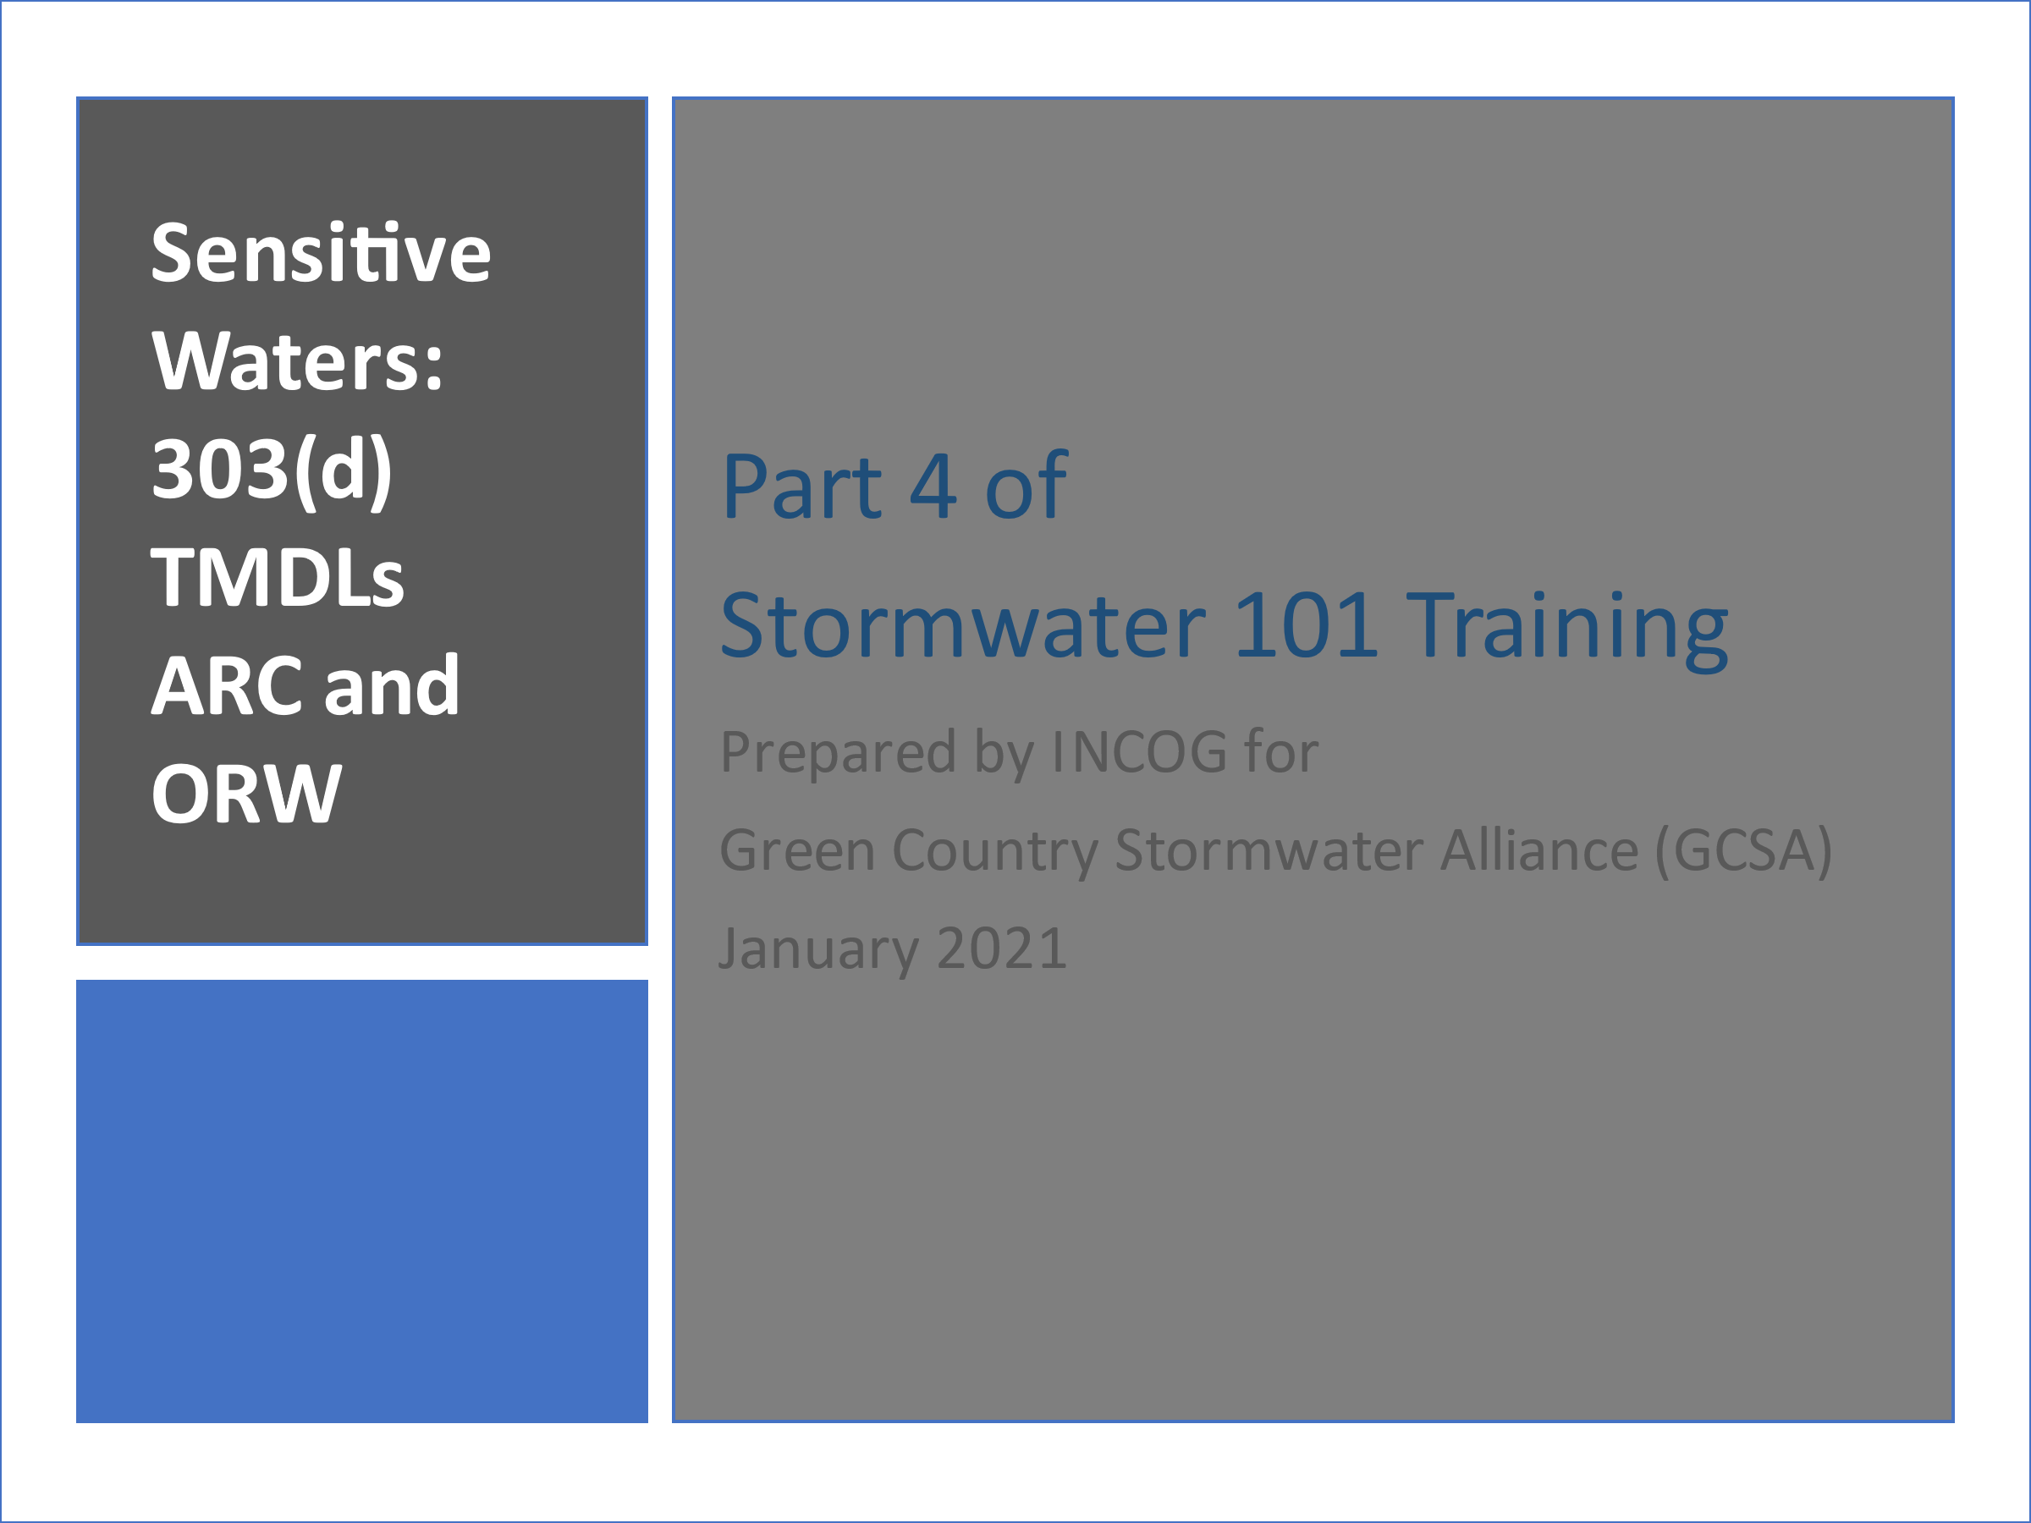
SLIDE 1: Welcome to the last of 4 Workbooks addressing the basics of stormwater permitting in Oklahoma, including city and county requirements under your permit.
Five Stormwater 101 Workbooks were planned, but all topics of Workbook 5 have been incorporated into the first 4.
Part 4 covers what can be called “sensitive waters”, referred to as “Special Conditions” in Part IV of the 2021 OKR04 permit. These are waterbodies that are 303(d) impaired, have completed TMDLs, are identified as Aquatic Resources of Concern (ARC) and/or as Outstanding Resource Waters (ORW).
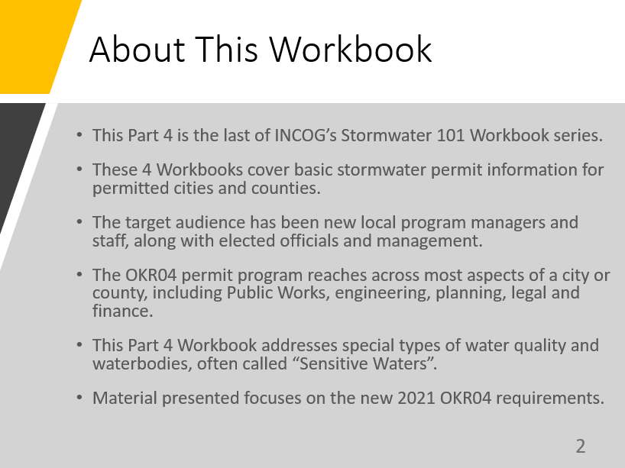
SLIDE 2: The OKR04 permit program affects many important aspects of municipal operations.
The local OKR04 Program Manager must have cooperation from many municipal departments, including Public Works, engineering, planning, legal and finance as well as support from management and elected officials.
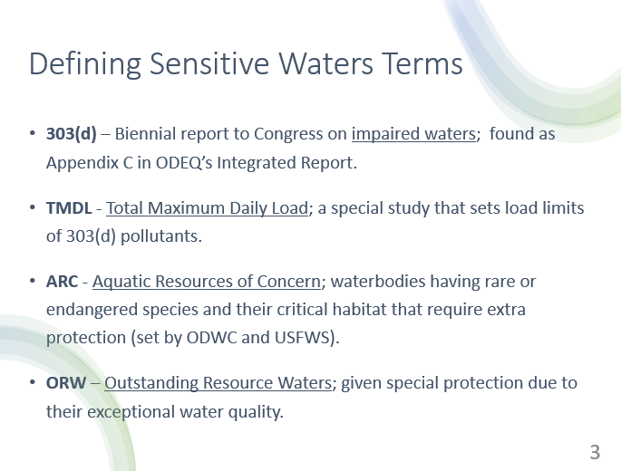
City or county management and elected officials must be knowledgeable about the OKR04’s many requirements. It is they who must approve compliance strategies and fund program implementation needs.
SLIDE 3: There are 4 categories of Sensitive Waters addressed in OKR04: 303(d), TMDLs, ARC and ORW.
303(d) is a section from the federal Clean Water Act that requires a report to Congress from each state biennially (every 2 years) listing all waterbodies determined to be impaired.
TMDLs are a special type of pollutant control study called a Total Maximum Daily Load usually performed on 303(d) listed waterbodies.
ARC (Aquatic Resources of Concern) are designated waterbodies or watersheds in Oklahoma needing special protections for endangered or threatened species and their critical habitat.
ORW (Outstanding Resource Waters) are defined in Oklahoma’s Water Quality Standards (WQS) as waterbodies of exceptional high quality needing special protections.
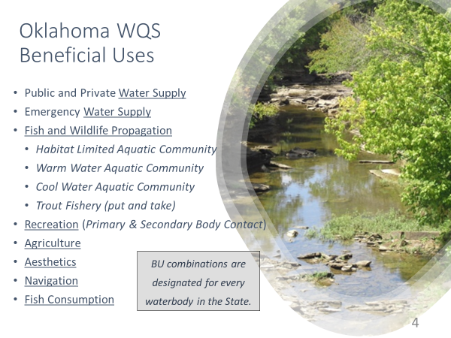
SLIDE 4: Oklahoma’s WQS are designed to protect how Oklahoma’s water resources are used. Categories of uses, called Beneficial Uses, include water supply, fish and wildlife propagation, recreation, agriculture, aesthetics, navigation and fish consumption.
Every waterbody in Oklahoma has Beneficial Uses assigned to it, depending upon how each waterbody is most likely to be used.
The WQS then assign numeric and non-numeric (“narrative”) criteria to protect each Beneficial Use.
Discharge permits issued by DEQ set limits on the amount of pollutants that can be discharged to protect the uses.
Stormwater permits are just another kind of discharge permit. They are written to ensure that Oklahoma’s WQS and Beneficial Uses are protected.
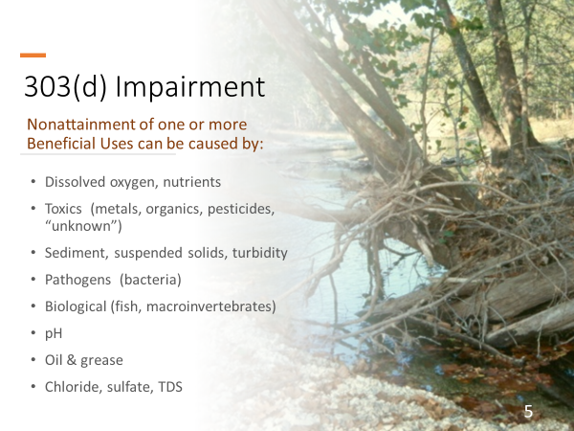
SLIDE 5: The causes of 303(d) impairment can be from any type of pollutant, such as too little dissolved oxygen, nutrients that cause excess algae growth, many types of toxic compounds and heavy metals, too much sediment, pathogenic bacteria, pH extremes, oil & grease, and too much salt (dissolved solids).
303(d) listings can also be defined for waters having fish or macroinvertebrate communities that are too stressed to support a healthy ecosystem.
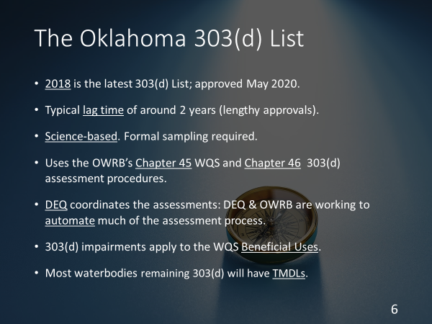
SLIDE 6: The latest version of the biennial 303(d) list was approved in May 2020. The list is actually Appendix C in Oklahoma’s more comprehensive “Integrated Report”.
It takes about 2 years to update the 303(d) list. The list date reflects when the process began, not when it was completed.
Oklahoma uses formal science-based procedures for making 303(d) impairment decisions. These are in Chapter 46 of the WQS, and they use the numerical and narrative criteria in Chapter 45 of the WQS to assess Beneficial Use “attainment”.
Most waterbodies that remain on the list will have a TMDL study to set pollutant limits so that impairment status can be remedied. A few waterbodies may have an alternative kind of study called a Watershed Based Plan. OKR04 requires that both TMDLs and Watershed Plans must be complied with by permitted MS4s.
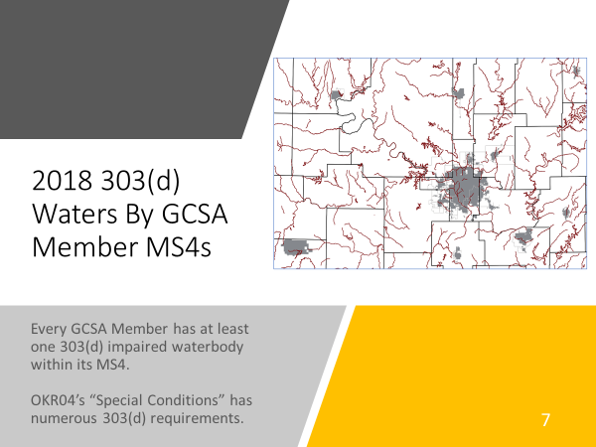
SLIDE 7: DEQ updates its 303(d) database and GIS layers every 2 years so that listed waterbodies can be located. These can be found in the Integrated Report posted on the DEQ website.
DEQ also updates its online interactive map website that also has web pages for downloading water quality data and GIS layers.
Every GCSA Member has at least one 303(d) impaired waterbody within its MS4 area. The OKR04 permit has a number of requirements permittees must implement to reduce the “Pollutants of Concern” (POCs) that cause the impairment.
The OKR04 permit lists many of these requirements under “Special Conditions” which is Part III of the existing OKR04 and will be Part IV of the new 2021 OKR04 permit.
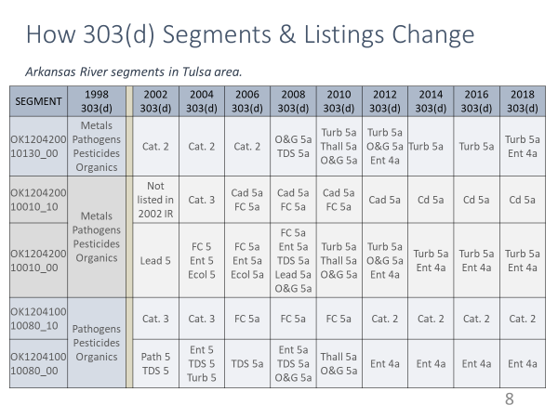
SLIDE 8: Two aspects of 303(d) listing can be problematic for MS4s.
First, segmentation of streams is not uncommon. This is where a single 303(d) stream segment is split into 2 or more segments. Each segment can be listed for its own set of impairment conditions.
Second, listed causes (POCs) can change with each 2-year cycle. This can pose problems for MS4s that have pursued Best Management Practices (BMPs) to address, say bacteria pollution, only to have to change BMPs to address dissolved oxygen (DO) because the segment’s 303(d) impairment status changed from having bacteria to DO problems.
This table shows how Arkansas River segments through the Tulsa metro area have changed over the past 20 years, both in segmentation and POCs. Fortunately these types of changes are happening less often than in the past.
It is urgent that each permitted MS4 stay informed about 303(d) status of all waterbodies within their MS4. Once a list is superseded by a later version, the old list is no longer valid. Only the new 303(d) list affects permit compliance.
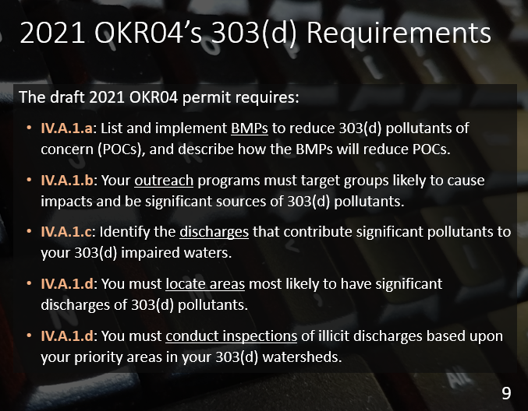
SLIDES 9 & 10: These 2 PowerPoint slides list the 2021 OKR04 text that requires each MS4 to implement strategies to reduce or eliminate the 303(d) causes of impairment.
Present 303(d) requirements are in Part III of the 2015 OKR04 permit. The draft 2021 OKR04 permit has revised Part III text into an updated Part IV.
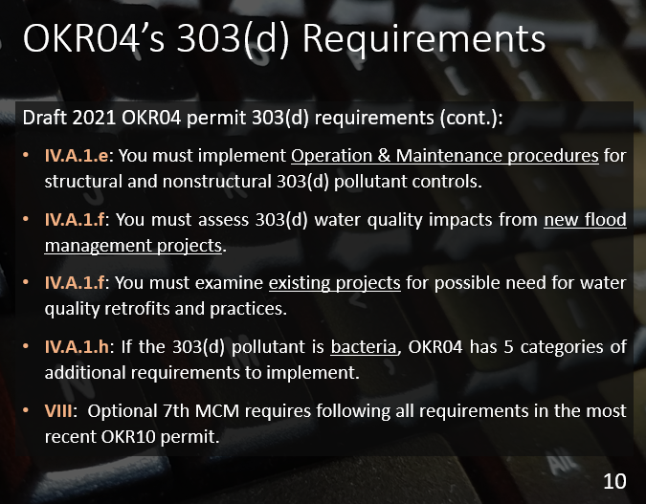
Permittees must adopt special BMPs for education outreach targeting the significant sources of POCs.
Inspections must be conducted within the 303(d) watershed within the MS4 to identify and control POC discharges.
Priority areas must be determined for targeted BMPs and inspections.
Operation and Maintenance procedures must be implemented that target POC discharges. New flood management projects must be assessed for 303(d) water quality impacts, and existing projects must be examined for potential water quality retrofits.
If the POC is bacteria (presently Enterococcus or E. coli in the WQS), OKR04 has 5 categories of actions that the MS4 must take to reduce bacteria pollution.
In addition, OKR04’s Part VIII, the optional minimum control measure (7th MCM) for municipal construction, requires compliance with the OKR10 construction permit that also has its own 303(d) requirements.
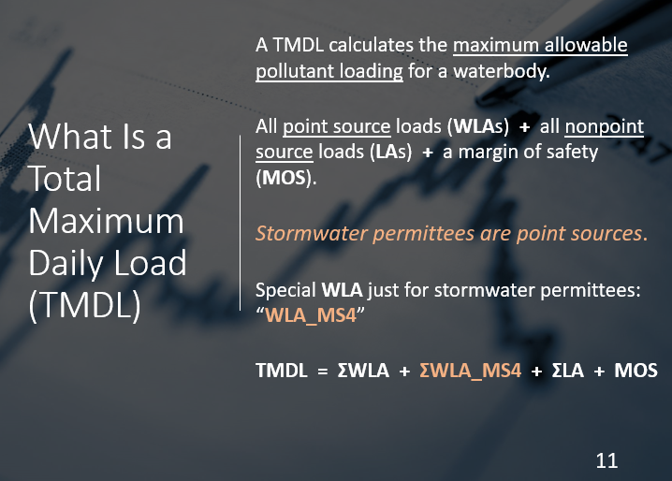
SLIDE 11: TMDLs are a very complicated subject, and their rollout by states and EPA has been problematic over the past 25 years.
A TMDL is a special water quality pollutant impact study of the entire watershed of the impaired waterbody.
The sum of all point source pollutant wasteload allocations (WLAs) are totaled, and they are added to the sum of all nonpoint source load allocations (LAs) to give a total pollutant load from the watershed.
Daily time frames are used, and the loads are in pounds per day (lbs/d) or for bacteria, in billions of bacteria cells per day. A Margin of Safety (MOS) is also calculated as a buffer in setting WLAs and LAs due to the uncertainties in the overall TMDL analysis.
Because permitted MS4 stormwater discharges are considered point sources, TMDLs having MS4s will use a special calculation just for MS4s, the WLA_MS4. Most TMDL studies also calculate a Percent Reduction Goal (PRG) for MS4s, such as 42% load reduction needed.
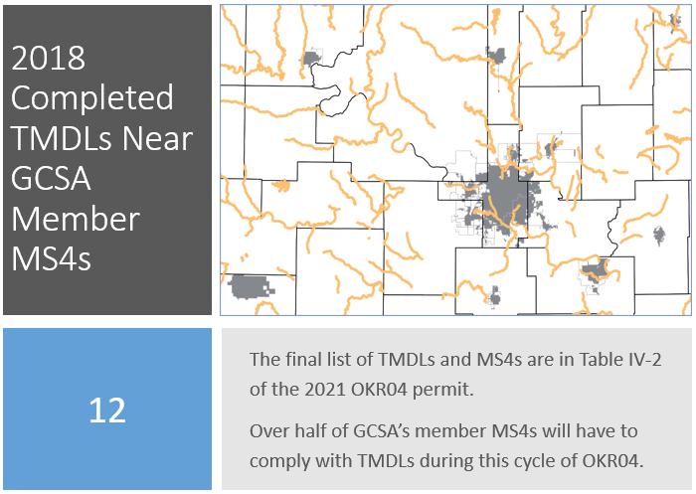
DEQ is allowing either the WLA_MS4 or the PRG to become the target for the MS4 to meet. Each MS4 must adopt their target load reduction as a Measurable Goal in their SWMP document.
SLIDE 12: The list of Completed TMDLs in Oklahoma is updated by DEQ every 2 years coinciding with the release of a new Integrated Report.
In the present 2015 OKR04 permit there are only general requirements to comply with TMDLs. This general strategy is changing significantly in the new permit.
Table IV-2 in the 2021 OKR04 lists specific TMDL Reports and all MS4s that must comply with the TMDLs in each report. The new permit also greatly expands TMDL compliance requirements for Table IV-2 MS4s.
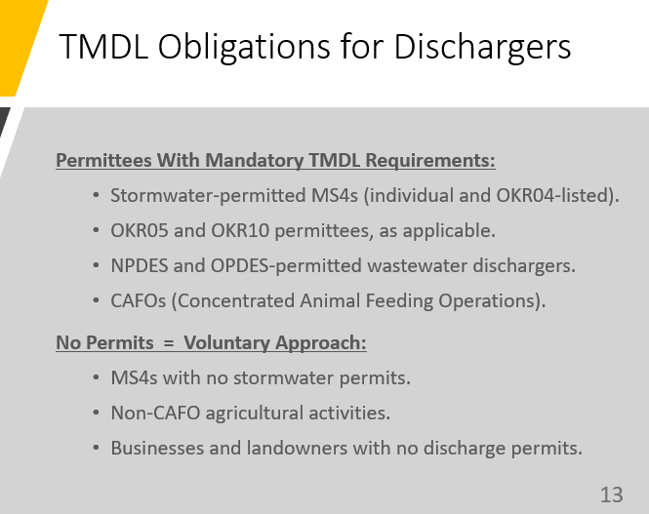
SLIDE 13: Not all dischargers and MS4s must comply with TMDLs in their area.
Only MS4s that are listed in Table IV-2 of the 2021 OKR04 permit must comply with OKR04’s new TMDL requirements.
OKR05 industrial and OKR10 construction stormwater dischargers may have TMDL requirements. Businesses that have wastewater permit discharges of POCs may also have to comply with TMDLs.
Most agricultural activities are exempt unless they have discharge permits such as Concentrated Animal Feeding Operations (CAFOs). Landowners and MS4s that do not have discharge permits do not have to comply with TMDLs.
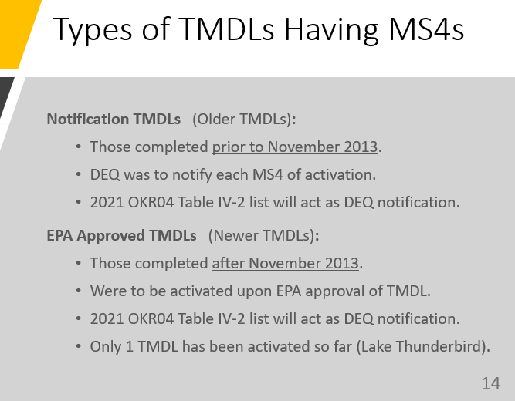
SLIDE 14: As TMDL reports began to be prepared in the 1990s, the reports stated that MS4s would have to begin complying with the TMDL “upon notification by the Director” [DEQ].
Until late 2013, DEQ did not issue any notifications to MS4s, so compliance was postponed. The one exception was the November 2013 Lake Thunderbird TMDL.
Since 2013, most TMDL Reports changed the text to state that MS4s must begin implementation upon EPA approval of the TMDL. However, DEQ postponed these new TMDLs pending development of a statewide TMDL compliance strategy for MS4s.
The 2021 OKR04 permit is the first rollout of DEQ’s new TMDL strategy for MS4s. Completed TMDLs with MS4s are listed in OKR04 Table IV-2. All other MS4s in Oklahoma in other TMDL watersheds do not have to comply with TMDLs at this time.
SLIDE 15: Most pre-2013 TMDLs in Oklahoma calculated a single combined WLA_MS4 load for all MS4s; individual WLA_MS4 loads were not assigned to each MS4.
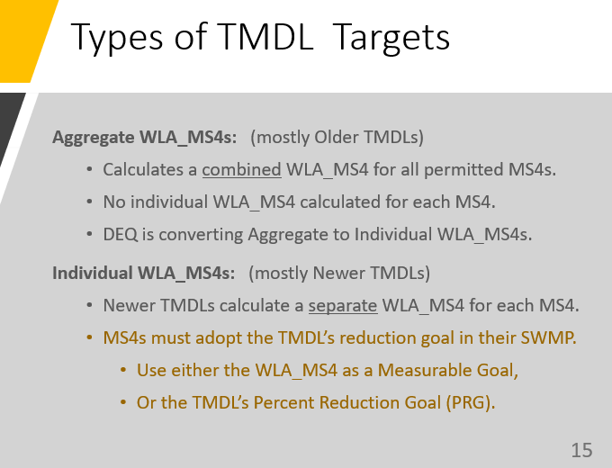
These are referred to as “Aggregate TMDLs”.
Meeting an aggregated MS4 load is not practical, so DEQ is calculating individual MS4 loads from those old TMDL aggregated loads for each MS4 listed in OKR04 Table IV-2.
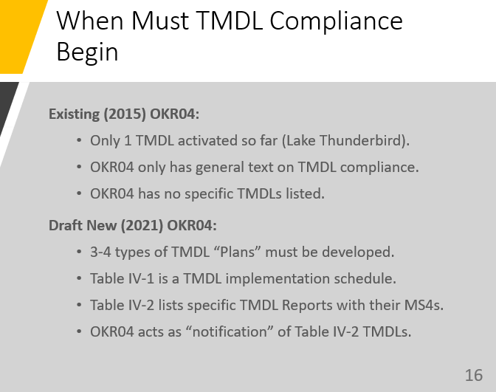
DEQ is also allowing flexibility in MS4 target selection in 2021 OKR04 by allowing an MS4 to set their assigned WLA_MS4 load as their target or use the PRG as their load reduction target.
SLIDE 16: The present OKR04 does not list specific TMDL Reports nor has lists of MS4s that must comply with TMDLs.
The 2021 OKR04 permit adds Table IV-2 showing specific TMDL Reports and all of the permitted MS4s within each report that must begin complying.
In effect, DEQ is “notifying” MS4s of their TMDL obligations with the finalization of the new OKR04. The permit’s “Effective Date” begins the schedule of all TMDL implementation activities.
OKR04 also has many pages of specific TMDL actions that must be taken by MS4s, including preparation of 3 to 4 types of Plans. These are discussed in greater detail in GCSA Fact Sheets and Workbooks from Zoom meetings. INCOG will work with DEQ to prepare GCSA guidance documents and education outreach on TMDL compliance. INCOG will also host training sessions on TMDLs.
SLIDES 17 & 18: When stormwater permits were first being prepared in Oklahoma, the US Fish and Wildlife Service (FWS) and the Oklahoma Department of Wildlife Conservation (ODWC) identified areas needing special protection for endangered and threatened species and their critical habitats.
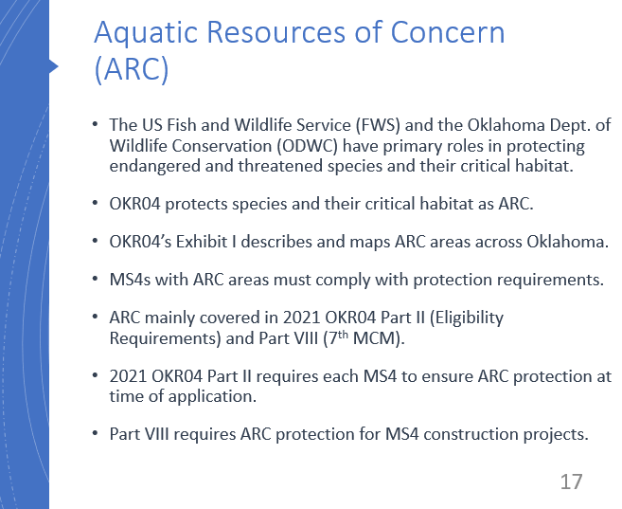
These areas are referred to as Aquatic Resources of Concern (ARC). Each of the 3 stormwater general permits has ARC areas listed along with an Oklahoma ARC map (see OKR04’s Exhibit I).
Most ARC protection requirements in OKR04 are in Part VIII, the optional 7th MCM for municipal construction.
ARC must also be considered when applying for permit coverage under OKR04’s Permit Eligibility section.
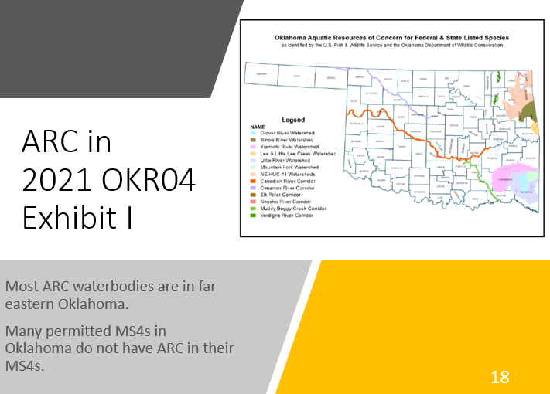
The MS4 must ensure that their activities under the OKR04 permit will not cause harm to species or their critical habitat.
Only those MS4s with ARC areas at least partly within their MS4 must comply with the ARC provisions in OKR04.
SLIDES 19: Outstanding Resource Waters (ORW) represent a few Oklahoma streams and watersheds of exceptionally high water quality deserving of special protection status in the Oklahoma WQS. Most prominent are the Oklahoma Scenic Rivers.
Only one permitted MS4 in Oklahoma, the City of Tahlequah, has MS4 area within one of these ORW areas.
As such, Tahlequah must meet a wide range of special protection requirements, including ensuring that their MS4 pollutant discharges do not exceed those that existed in 1992.
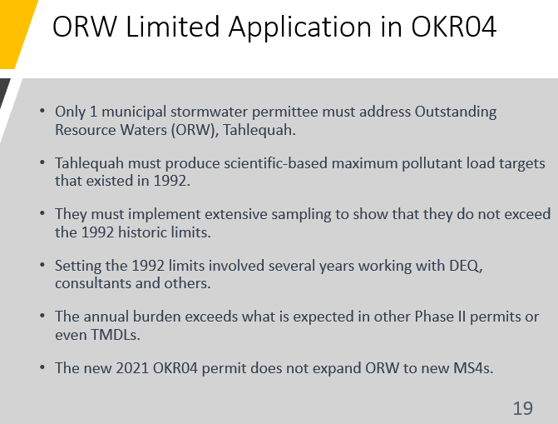
Significant resources have been devoted to this effort by Tahlequah, and their responsibilities will be ongoing as long as the Illinois River and its tributaries have ORW protection.
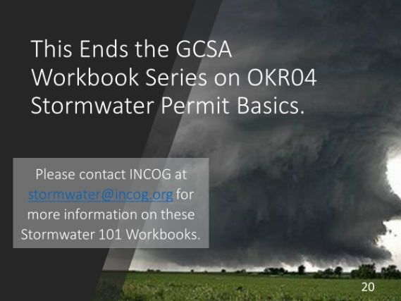
The proposed new 2021 OKR04 permit does not expand upon any ORW requirements nor identify any additional MS4s.

SLIDES 20: This concludes the 4-part Stormwater 101 Workbook series by INCOG for its GCSA Members.
Over the past year, a third of GCSA Member program managers have been replaced by new people, most of whom do not have a thorough background in OKR04 permitting or water quality protection.
INCOG continues to develop education outreach guidance and information which is presented in a growing variety of media, including Zoom Meetings and these narrated PowerPoints with companion Workbooks.
Please contact INCOG at stormwater@incog.org or (918) 579-9451 if you have any questions about this material.

INCOG DISCLAIMER: The information provided by INCOG does not necessarily reflect the views and positions of other persons or agencies. Please consult DEQ stormwater staff for information about stormwater permit requirements, implementation, assessments and enforcement. Also, contact INCOG for information about INCOG’s Green Country Stormwater Alliance (GCSA) or this document.

